PS-02
Log File Anomaly Explainer Tool
AI-Powered CLI for On-Call Engineers — Instant Root Cause Analysis from Log Files
AI Engine | Google Gemini LLM
Language | Python 3.10+
Architecture | Tool-Using Agent (4 tools, up to 10 iterations)
Team | Team Apex Intelligence · 2026

1. Problem Statement
On-call engineers are overwhelmed by hundreds or thousands of log lines during a live outage. Three core challenges exist:
- Information Overload: No quick mechanism to isolate the critical failure block from thousands of lines.
- Slow Root Cause Analysis: Manually scrolling logs wastes critical minutes during live incidents.
- No Actionable Guidance: Engineers must mentally translate cryptic log messages into remediation steps under pressure.

“On-call engineer pastes 100s of log lines and asks: 'What went wrong?' — No automated, intelligent tool exists that takes raw log input and returns structured, actionable RCA.”

2. Our Solution
A two-mode Python CLI tool: fast Direct LLM explain and an agentic investigate mode with iterative LLM tool calls.

Mode | Description
explain (Direct) | Scans log → finds highest-severity error → extracts ±20-line context → sends to Gemini → outputs Markdown RCA report in seconds.
investigate (Agent) | LLM autonomously calls 4 tools iteratively (up to 10 rounds) to investigate the full log before producing a deep analysis.
Output Formats | Rich console (colour terminal UI) · Markdown report file · JSON (for pipeline integration)

3. System Architecture
Five tightly-integrated Python modules plus the Google Gemini LLM API:

Component | Module | Responsibility
CLI Entry | cli.py | Click commands: explain / scan / investigate. Routes output to console, JSON, or Markdown.
Anomaly Parser | parser.py | Regex severity scan (scores 1–6). Identifies primary error line, extracts ±20-line context window.
Data Model | AnomalyBlock | Dataclass: primary line #, context lines, severity score, file path, total lines, context range.
LLM Client | llm_client.py | Constructs SRE-persona prompt, calls Gemini API, parses structured response sections.
Agent Engine | agent.py | Tool-using loop: dispatches LLM function calls, collects results, iterates up to 10 times.
Tool Registry | tools.py | 4 functions: scan_all_anomalies, parse_log_file, read_log_lines, search_log_pattern.

Data flow:
.log File → cli.py → parser.py → AnomalyBlock
├── llm_client.py (Direct mode)
└── agent.py + tools.py (Agent mode)
└── Google Gemini LLM API → Markdown Report
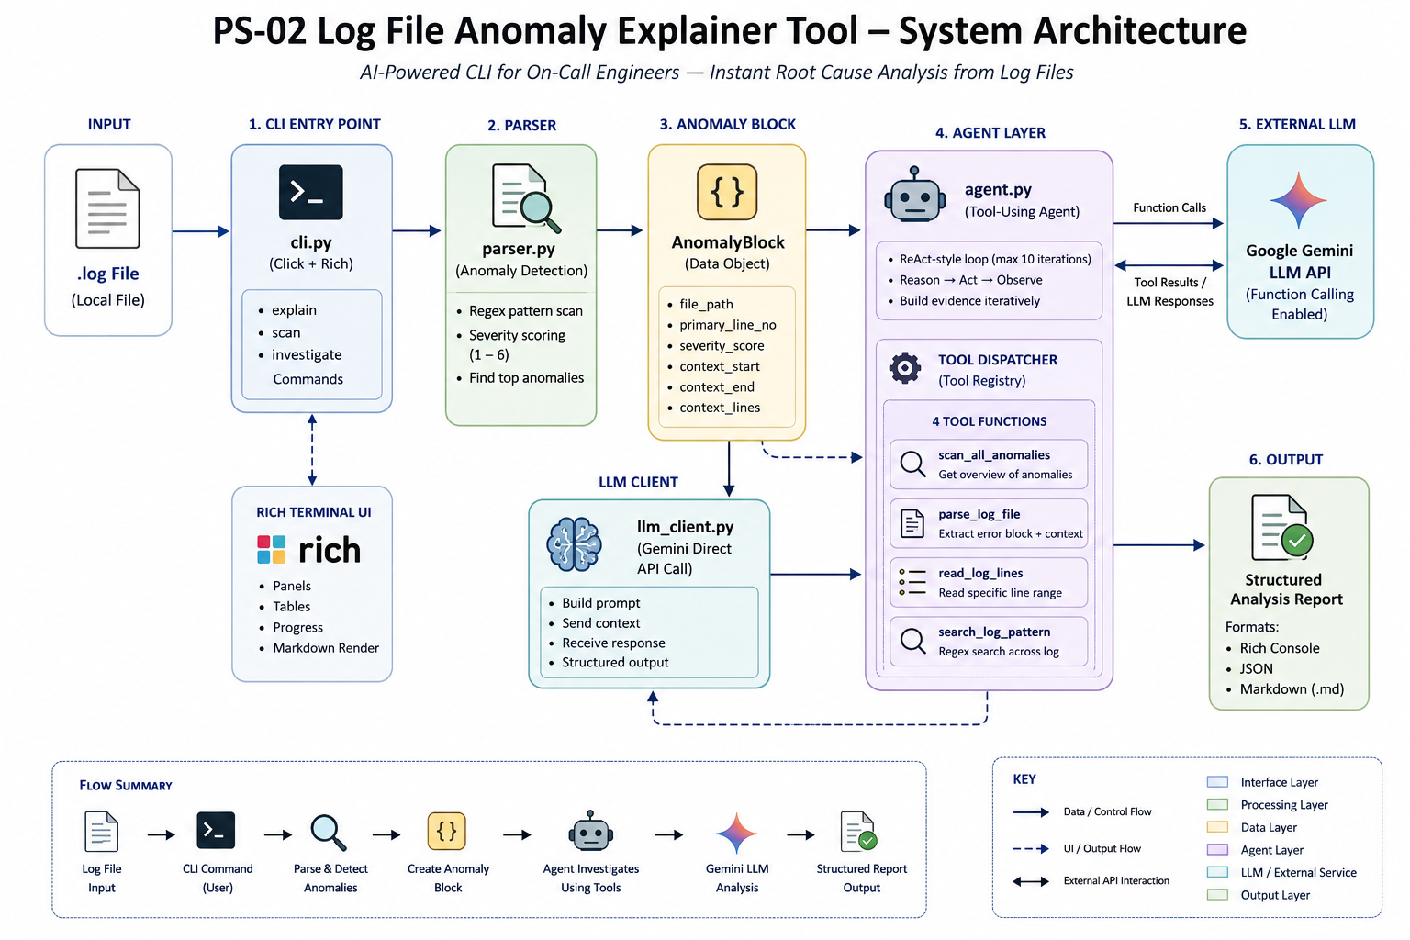

4. Technology Stack
Technology | Role & Reason
Python 3.10+ | Core language — dataclasses, type hints, pathlib, re (regex engine).
Google Gemini | LLM analysis + function calling via google-genai SDK.
Click | CLI framework — clean sub-command routing (explain / scan / investigate).
Rich | Terminal UI — colour panels, tables, live progress, inline Markdown rendering.
python-dotenv | Secure API key loading from .env file.
uv / pytest | Fast package manager and unit test framework.

5. Workflow

5.1 Direct Explain (explain command)
- Input: Engineer runs: log-explainer explain app.log
- Parse & Score: parser.py scans every line against severity patterns (FATAL=6 … WARNING=1).
- Extract Context: ±20 lines around the primary error extracted. Primary line marked with >>>.
- LLM Analysis: Structured SRE-persona prompt submitted to Gemini with full context block.
- Report Output: Sections parsed — Root Cause / Probable Cause / Remediation Steps / Confidence (HIGH|MEDIUM|LOW).
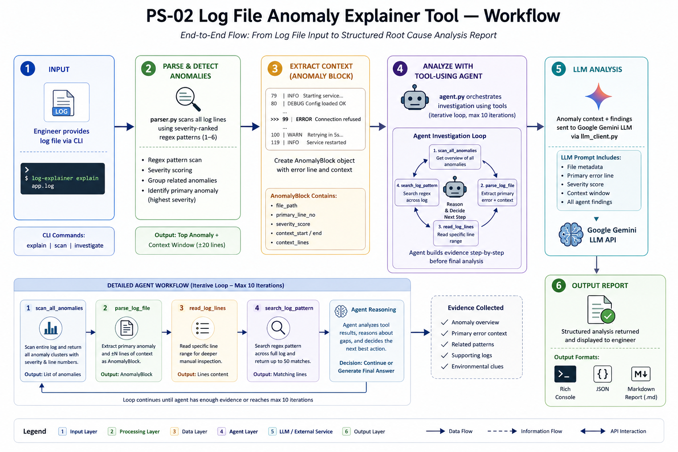

79 | INFO Starting service... 80 | DEBUG Config loaded OK
81 | WARN Disk usage at 87% ... >>>99 | ERROR Connection refused
100 | WARN Retrying in 5s... ... 119 | INFO Service restarted

5.2 Agent Investigation (investigate command)
- agent.py initialises Gemini with all 4 tool definitions as function declarations.
- LLM decides which tools to call — typically starts with scan_all_anomalies for an anomaly map.
- Tool results are appended to conversation history; LLM reasons over them and calls more tools.
- Loop repeats up to 10 iterations with live Rich UI progress. Final structured analysis produced.

6. Anomaly Detection Engine

6.1 Severity Scoring
Pattern | Examples | Score
FATAL / CRITICAL / panic | FATAL: unhandled exception, kernel panic | 6
OOM / segfault / killed | Out of memory: Kill process, segfault | 6 / 5
EXCEPTION / Traceback | NullPointerException, Traceback | 4
ERROR | ERROR connecting to DB, ERROR 500 | 3
Timeout / Conn refused | operation timed out, Connection refused | 2
HTTP 4xx/5xx | HTTP 503 Service Unavailable | 2
WARNING / WARN | WARN: high memory, disk at 87% | 1

6.2 Prompt Engineering
System instruction sets SRE-Expert persona with strict ## section headers for deterministic parsing. User prompt injects: file path, total lines, primary line number, context range, severity score, and the formatted context block. Output parsed by section header search — no regex on the response side.

7. Sample Analysis — Thunderbird_2k.log
Field | Value
Primary Line | #99
Context Range | Lines 49–149
Severity | 2 / 6
Confidence | HIGH
Model | Gemini Flash
Anomalies Found | 4 across 2,000 lines

Root Cause
The sendmail service fails to deliver mail because no process is listening on port 25 of 127.0.0.1 — the local MTA is not running or misconfigured.

Probable Cause
MTA crash across nodes (eadmin1, badmin1) correlated with gmetad timeouts, indicating broader cluster instability — possibly OOM-induced process termination.

Remediation Steps
- systemctl status sendmail — verify service state
- netstat -plnt | grep :25 — confirm nothing listening on port 25
- Verify FQDN in /etc/hosts · Check OOM events in dmesg · Check disk saturation

Additional Anomalies
- vesafb probe error — GPU framebuffer init failure (non-critical)
- sshd port conflict — SSH bind failure on secondary interface
- Cluster instability — gmetad monitoring timeouts across nodes

8. Applications & Real-World Use Cases
Use Case | User | Benefit
Incident Response | On-call SRE / DevOps | Instant AI-powered RCA during live outages — no manual log triage.
Post-Mortem Analysis | Engineering Manager | Auto-generate root-cause reports from historical log archives.
CI/CD Pipeline QA | Build Engineers | Detect failure patterns in test run logs; fail build with AI explanation.
DevOps Automation | Platform Engineering | Trigger alerts and automated remediation on detected anomaly patterns.
Developer Onboarding | Junior Engineers | New team members understand production errors faster via AI context.
Multi-Service Monitoring | SRE / Platform Teams | Batch-scan logs from microservices, cloud infra, and servers in one run.

9. Key Takeaways
Feature | Implementation | Impact
Automated Detection | Severity-ranked regex, 7 pattern tiers | Finds anomalies instantly across 10+ error types — zero ML required
Context-Aware AI | ±20-line window with >>> primary marker | Gives Gemini the system state needed for accurate RCA
Agent Architecture | 4-tool iterative loop, up to 10 iterations | LLM investigates complex multi-anomaly logs like an expert SRE
Production Ready | Rich CLI, JSON/Markdown output, unit tested | Deployable in real on-call workflows and CI/CD pipelines
Zero ML Dependency | Pure regex + LLM API | No training, no dataset, no GPU — runs anywhere Python 3.10 runs

log-explainer explain app.log → Instant AI-Powered Root Cause Report

Team PS-02 · Log File Anomaly Explainer · 2026

